 **Name___________________________**

**Maths Specialist - Investigation**

**Circle Geometry- Part Two**

**Extended investigation Part 2:** **In-class validation**

**Question 1 (6 marks)**

Write a description of the theorem next to the diagram.

(a) Angle in a Semicircle (1)

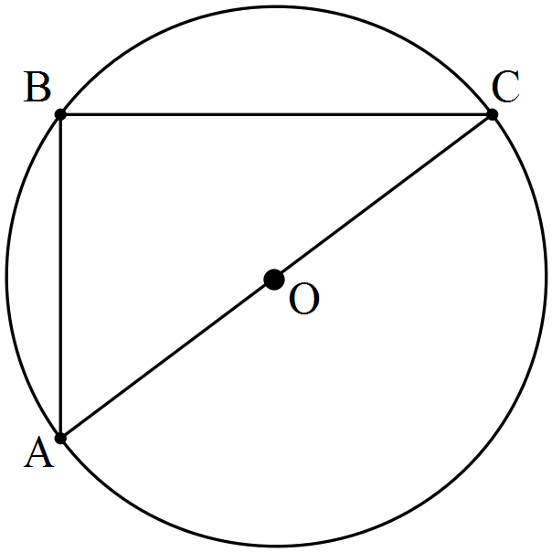

(b) Central Angle Theorem (1)

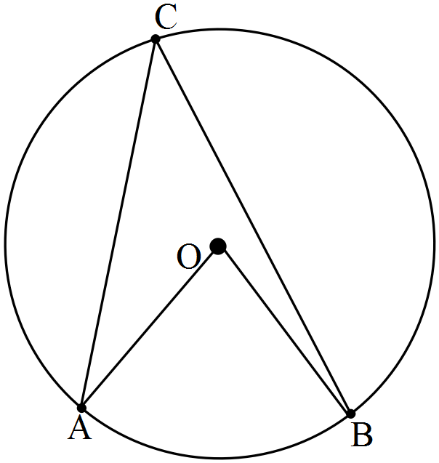

(c) Angle in the Alternate Segment Theorem (1)

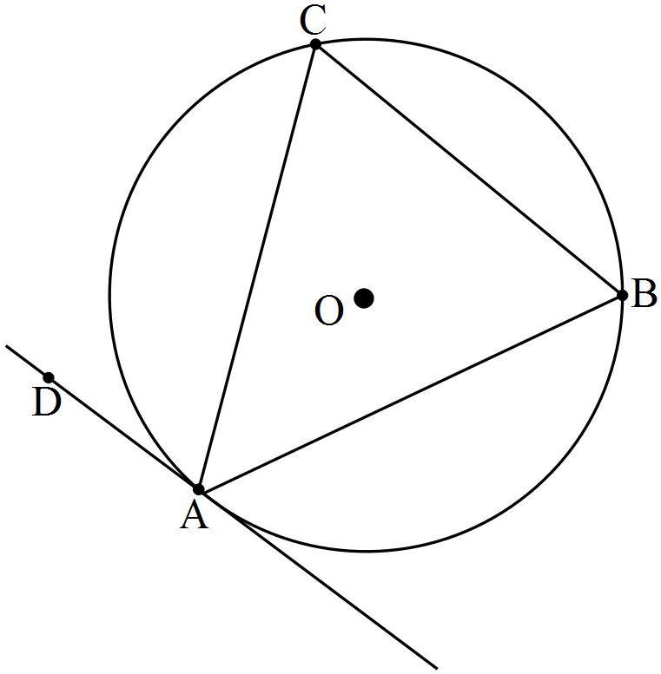

(d) Length of Tangents Theorem (1)

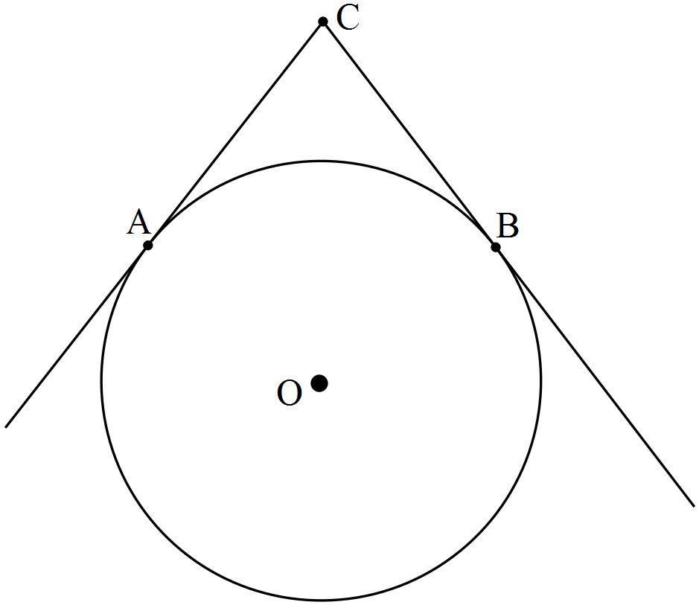

e) Intersecting Chords Theorem (1)

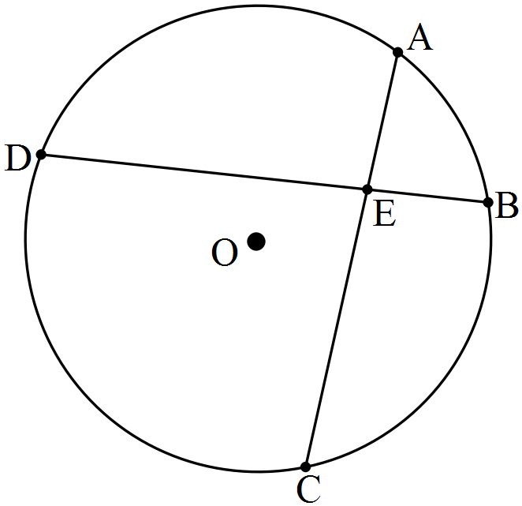

(f) Angles at the circumference of a circle subtended by the same arc. (1)

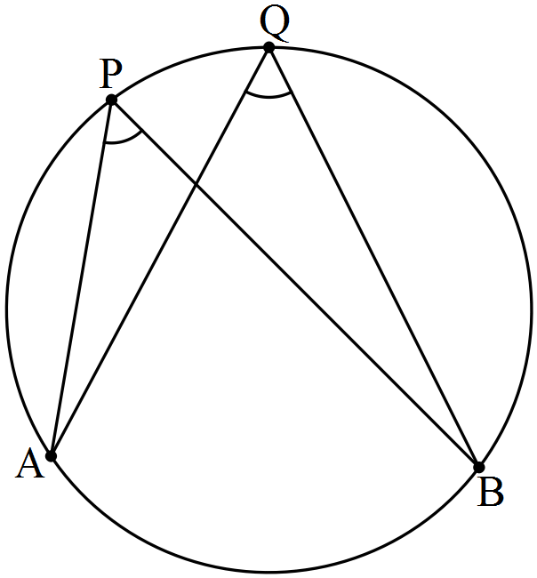

**Question 2 (5 marks)**

Complete the following proof.

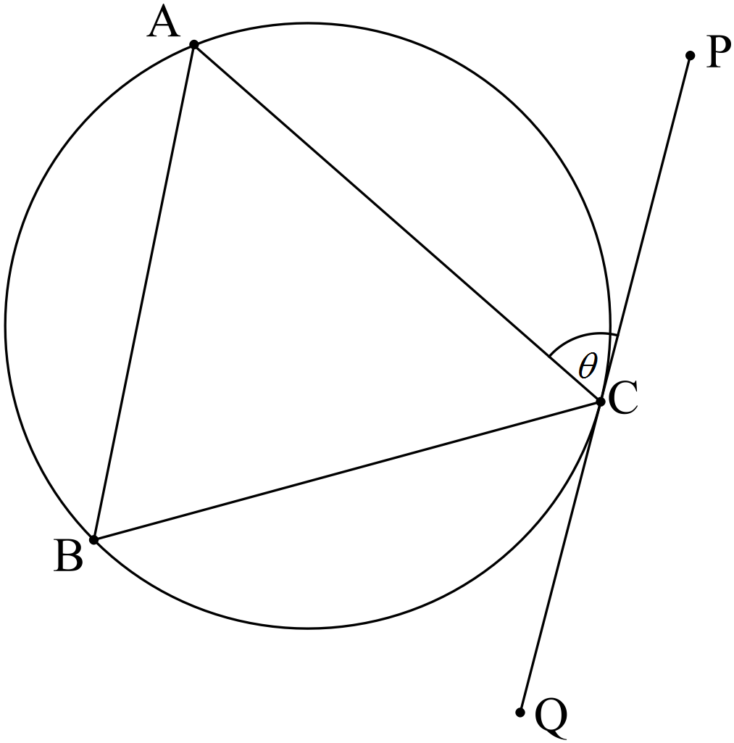

Given: PQ is tangential to the circle at C, CA = CB, .

To Prove: PQ is parallel to AB.

Proof:

**Question 3 (5 marks)**

Complete the following proof.

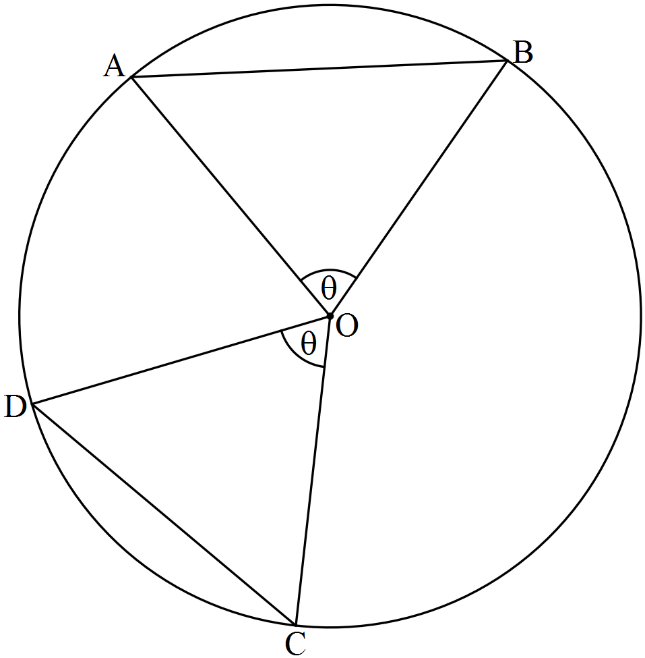

Given: Circle centre O with chords AB and CD, .

To Prove: Chords AB and CD are equal in length.

Proof:

**Question 4 (4 marks)**

Complete the following proof.

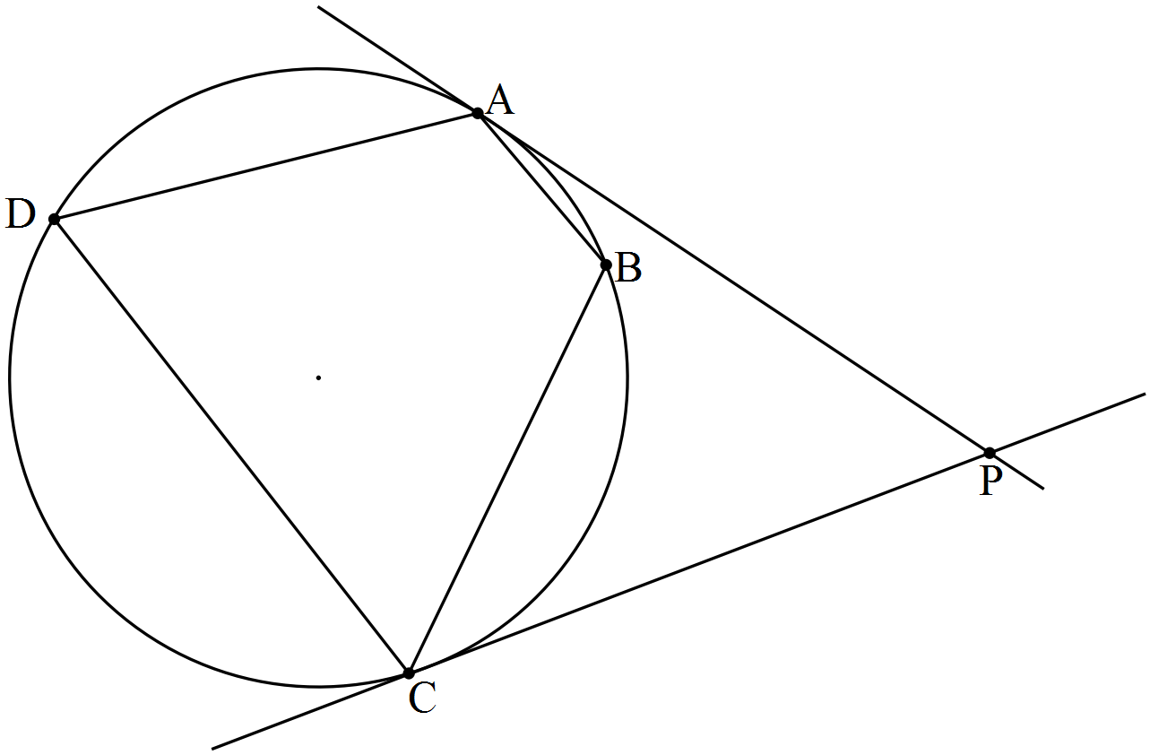

Given: A, B, C and D are four points on a circle such that ABC form a minor arc of the circle. The tangents at A and C meet at P.

To Prove: 

**Question 5 (6 marks)**

Complete the following proof.

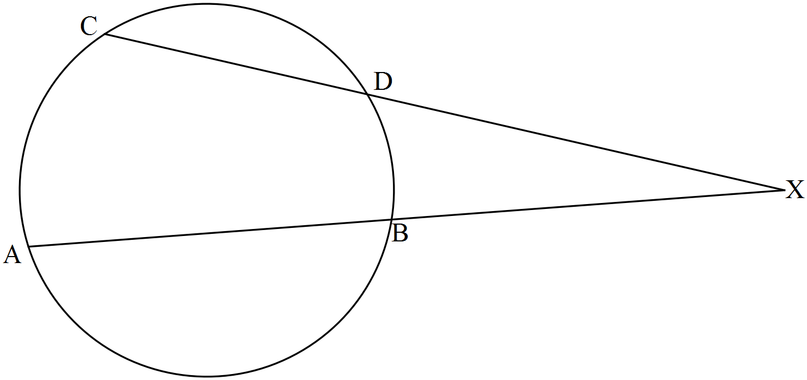

Given: Circle centre O with chords AB and CD intersecting externally at X.

To Prove: XA.XB = XC.XD

**Question 6 (5 marks)**

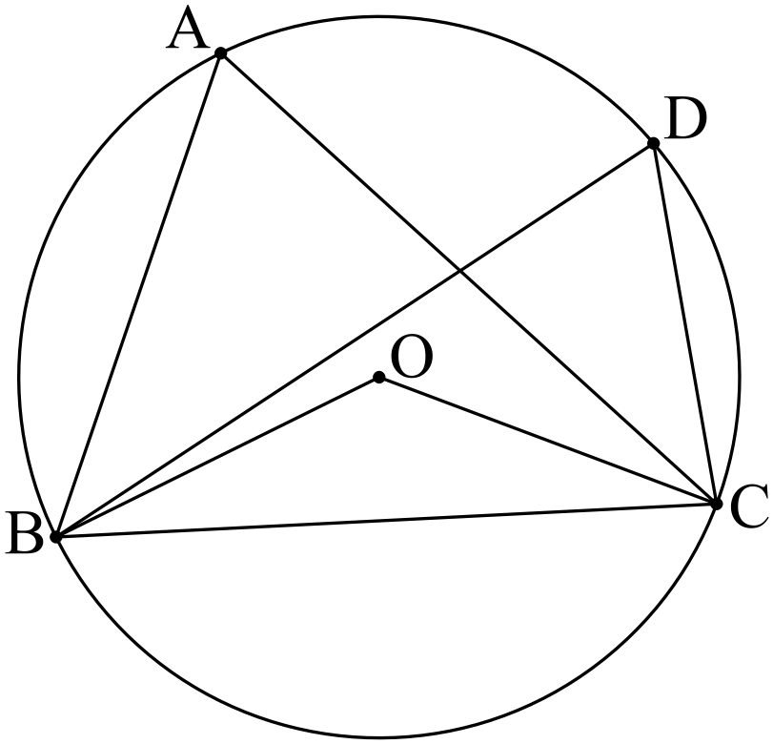

Given  and , determine the size of 

**Question 7 (6 marks)**

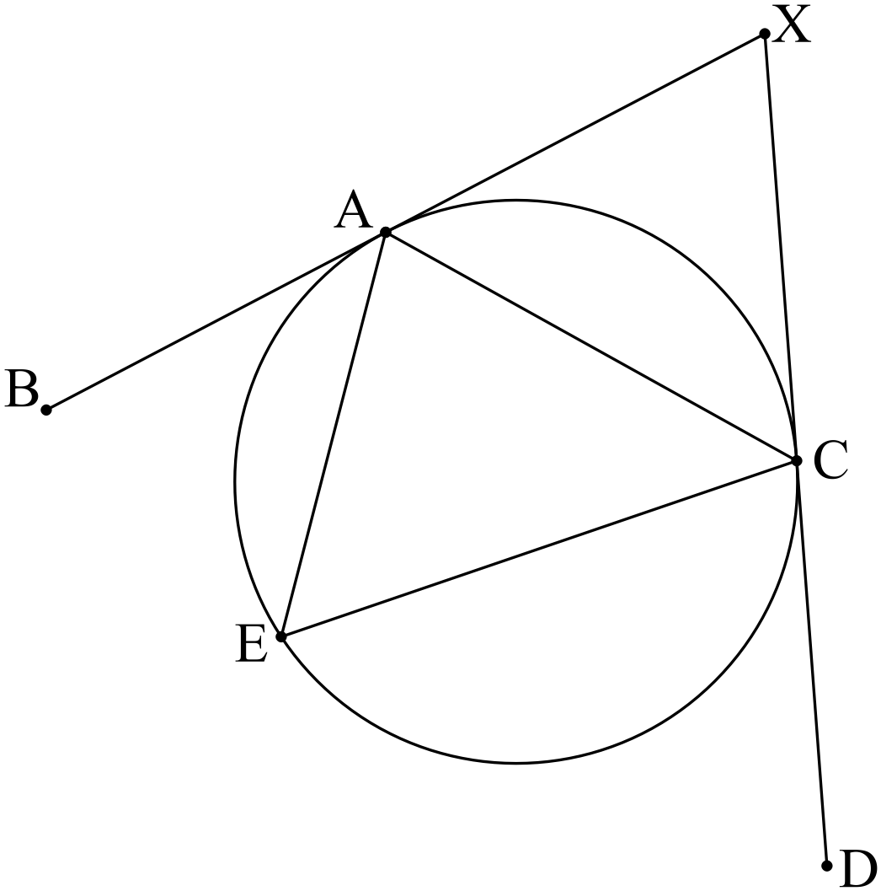

Given XB and XD are tangents,  and , determine the size of 